1. Controllers

Perhaps one of the most important parts of the robot is the controller. Which is the brain of the system. Granted, to be able to fully utilize the controller, sensors and actuators are also needed. Controllers are able to interface the sensors with the actuators. Which allows us to control the outputs of the actuators based on inputs of the sensors. Controllers vary in complexity, efficiency, and ease of use.

* 1. Arduino

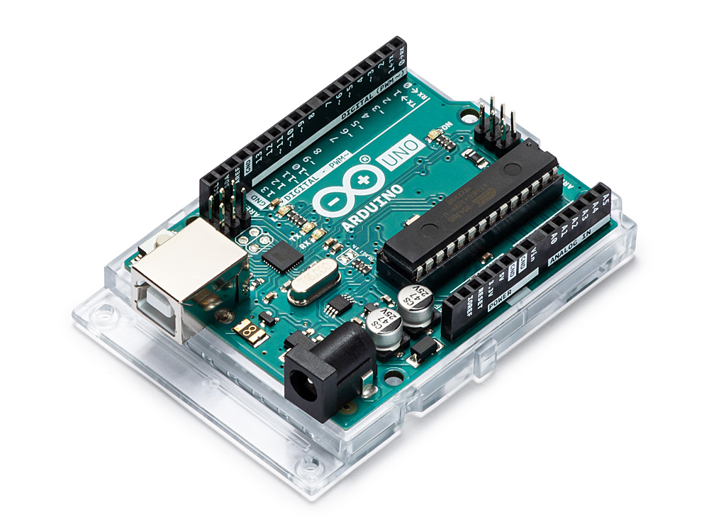Arduino boards are one of the most popular boards in DIY projects used by both hobbyists and professionals. An Arduino board is a microcontroller board containing many different things including RAM, IO ports, and the microcontroller itself. There are different types of Arduino boards that differ in both size and capabilities. The most popular type might be the Arduino uno which is based on the ATmega328P microcontroller. Arduino boards also contains a part of the integrated development enviroment (IDE) that is used to program it. The Arduino IDE uses a basic version of C++. [1]

Figure 1 - Arduino uno board

* 1. Raspberry Pi

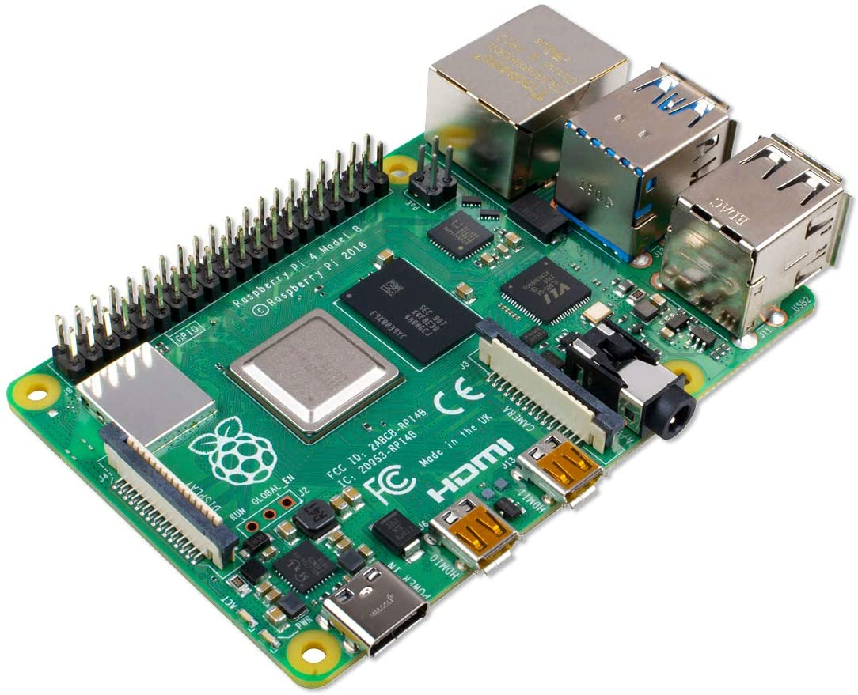Raspberry Pi is called a single board computer (SBC) it functions basically like a full computer, an operatic system can be installed on it and the user can connect a monitor, mouse and keyboard to it. Raspberry Pi(s) are Linux based computers although different a different operating system like android can be installed on it. A Raspberry Pi has a clock speed that is much higher than even an Arduino mega (1.2 GHz vs 16 MHz). [2]

Figure 2 - Raspberry Pi 4

1. Impact of engineering solution on society.

The robot might boost productivity by allowing students and faculty members to reduce the time wasted on delivering or picking up things from around the campus. However, it might also have a negative effect on people. One of the possible negative effects is that our robot might promote laziness. Because people would get used to receiving things with minimal movement.

1. Impact of parts on society
   1. Stereo camera

Although using a stereo camera can facilitate obstacle avoidance and navigation, some people might be opposed to it due to privacy concerns. People might be bothered by seeing a robot equipped with a camera roaming around campus thinking that they are being recorded. To mitigate that effect, we could put notes that state that no camera footage would be published anywhere unless necessary by law.

* 1. Motors

Motors are crucial in any type of robot that is expected to move. Nevertheless, it might cause some disturbance to students and faculty members due to the noise. Although according to a survey done as a part of a research project, most people are only mildly annoyed by electric scooter noise in comparison to combustion scooters. [3]

1. References

[1] “Types of Arduino Boards : Working and Their Comparision.” https://www.elprocus.com/different-types-of-arduino-boards/ (accessed Nov. 19, 2021).

[2] “What are the differences between Raspberry Pi and Arduino?” https://www.electronicshub.org/raspberry-pi-vs-arduino/ (accessed Nov. 19, 2021).

[3] A. Fiebig, P. Marla, and R. Sottek, “Noise of electric and combustion-powered scooters and resulting annoyance,” *Proc. - Eur. Conf. Noise Control*, pp. 1069–1074, 2012.

<https://www.researchgate.net/publication/289853403_Noise_of_electric_and_combustion-powered_scooters_and_resulting_annoyance>

<https://www.polisnetwork.eu/wp-content/uploads/2019/06/07-scooters-noise-of-electric-and-combustion-powered-scooters_fiebig.pdf>